Progression in written calculation strategies for multiplication (Examples indicate end of year expectations)
Reception | Year 1 | Year 2 | Year 3 | Year 4 | Year 5 | Year 6
LION  Statutory Guidance  Solve problems, including doubling, halving and sharing  Double 5    Non-statutory  Count in 2s, 5s and 10s    5 10 15 20 | LEOPARD  Statutory Guidance  Solve one-step problems involving multiplication by calculating the answer using concrete objects, pictorial representations and arrays with the support of the teacher.  Possible representations  e.g. 2 lots of 3 =  There are two bowls with three apples in each. How many apples are there altogether?    Non- Statutory guidance  They make connections between arrays, number patterns, and counting in twos, fives and tens. | PANTHER  Statutory Guidance  Solve problems involving multiplication using materials, arrays, repeated addition, mental methods, and multiplication facts, including problems in contexts.  Possible representations  1x3  15  12  9  6  3  0  1x3  1x3  1x3  1x3  e.g. 5 x 3 =  5 x 3 =  3 x 5 =  Multiplication facts include: 2, 3, 5 and 10 | TIGER  Statutory Guidance  Write and calculate mathematical statements for multiplication using the multiplication tables that they know, including for two-digit numbers times one-digit numbers, using mental and progressing to formal written methods.  Multiplication facts include: 2,3,4,5,8 and 10  Key strategy:  Partitioning the two-digit number into tens and ones  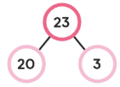  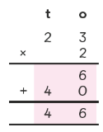  Children should use base ten to understand multiplication by multiples of 10 e.g. if 2 x 4 = 8 then 20 x 4 = 80  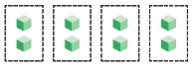  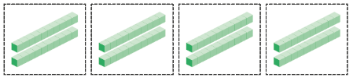 | JAGUAR  Statutory Guidance  Multiply two-digit and three-digit numbers by a one digit number using the formal written layout.  Key strategy:  Short multiplication  Expanded  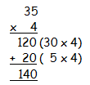  Compact  7  4  3  x  7  3  9  2  4  2  4  Multiplication facts up to 12 x 12 | LYNX  Statutory Guidance  Multiply numbers up to 4 digits by a one – or two-digit number using the formal written method,  Key strategies:  Short multiplication  1  4  7  x  6  2  6  4  4  6  4  2  1  Long multiplication – introduced using an area model first e.g. 28 x 26  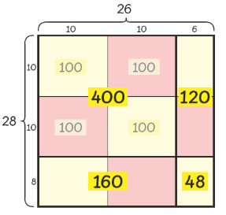  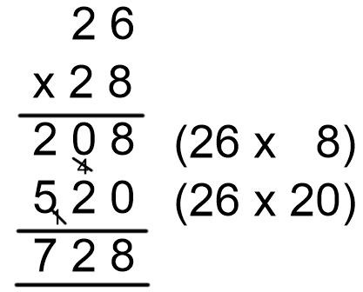 | PUMA  Statutory Guidance  Multiply multi-digit numbers up to 4 digits by a two-digit whole number using the formal written method of long multiplication.  Key strategies:  Long multiplication  e.g. 2741 x 66  