

PUPIL MENTAL HEALTH AND WELLBEING
Winford Church of England Primary School
Non-Statutory

Model Policy approved by Trust Executive Team
  Signed: | Date: 15/09/25
Name: Jenny Campbell | Role: Headteacher/Senior Mental Health Lead

Document History
Version | Author/Owner | Drafted | Comments
1.0 | J Camobell | 15/09/25 | Updated with school context
2.0
3.0
4.0
5.0

Date Policy Adopted
Review cycle
Review date

This policy applies to Winford Church of England Primary School

PUPIL MENTAL HEALTH AND WELLBEING
Non-Statutory

Contents

1. Context and Aims 2
2. Legislation and guidance 4
3. Roles and responsibilities 4
4. Procedure to follow in a case of acute mental health crisis Error! Bookmark not defined.
5. Warning signs 5
6. Managing disclosures 6
7. Confidentiality 6
8. Supporting pupils 7
9. Supporting and collaborating with parents/carers 10
10. Supporting peers 10
11. Signposting 11
12. Whole school approach to promoting mental health awareness 11
13. Training 11
14. Support for staff 12
15. Monitoring arrangements 12

Context and Aims
We recognise that children and young people’s mental health is a crucial factor in their overall wellbeing and can affect their learning and achievement. All children go through ups and downs during their school career and some face significant life events. Some children have a diagnosable mental health need and this can have an enormous impact on quality of life, relationships and academic achievement. In some cases, it can have a life-long impact. For children to be able to flourish in line with our vision, it is important for them to be supported in this.
The Department for Education (DfE) recognizes that: “in order to help their children succeed; schools have a role to play in supporting them to be resilient and mentally healthy”.
Our aim is to help develop the protective factors which build enable all to flourish by building resilience to mental health problems and to be a school where:
- All children/ young people are valued.
- Children/young people have a sense of belonging and feel safe.
- Children feel able to talk openly with trusted adults about their concerns without feeling any stigma.
- Positive mental health is promoted and valued.
- Bullying is not tolerated.
In addition to children’s wellbeing, we recognise the importance of promoting staff mental health and wellbeing. (Please see the LSP Staff wellbeing policy for further information)
At Winford Primary, we are committed to supporting the mental health and wellbeing of pupils, parents, carers, staff and other stakeholders.
This policy focuses on pupils' mental health and wellbeing. It aims to:
- Set out our school's nurturing approach to promoting positive mental health and wellbeing for all pupils across our school.
- How we train and support all staff to understand mental health issues and spot early warning signs to help prevent or address mental health difficulties
- How we identify and support children/ young people with mental health needs.
- Outline where parents/ staff and children can get further advice and support.

Across Lighthouse Schools Partnership (LSP), schools have been using a framework set out by Nurture UK to evaluate our school environments, policies and practices and draw up a plan to develop this work further. At Winford, we have worked with the children, parents and staff at our school to look at what nurture means to us and how we embed the six principles below into our school systems for the benefit of our children. The 6 principles of Nurture:
- Children’s learning is understood developmentally
- The classroom offers a safe base
- The importance of nurture in the development of wellbeing
- Language is a vital means of communication
- All behaviour is communication
- The importance of transition in children’s lives.

Winford Primary is working towards becoming a Nurture School with Nurture UK.
This policy should be read alongside:
- SEND policy
- Behaviour policy
- Anti-bullying policy
- Child protection and safeguarding policy
- Staff wellbeing Policy
- Attendance policy

2. Legislation and guidance
This policy was written with regard to:
- The Equality Act 2010
- The Data Protection Act 2018
- Articles 3 and 23 of the UN Convention on the Rights of the Child
- Supporting Mental Health and Behaviour in Schools Nov 2018
- Promoting and supporting mental health and wellbeing in schools and colleges (2021)
- Summary of responsibilities where a mental health issue is affecting attendance. DFE Feb 23

3. Roles and responsibilities
All staff are responsible for promoting positive mental health and wellbeing across our school and for understanding risk factors. If any members of staff are concerned about a pupil’s mental health or wellbeing, they should inform the Headteacher who is the designated safeguarding lead (DSL)/mental health lead.
Certain members of staff have extra duties to lead on mental health and wellbeing in school. These members of staff include:
- Headteacher/Designated safeguarding lead (DSL) (Mrs Campbell)
- Deputy Head/ Deputy Designated safeguarding lead (Mrs Tiernan)
- Special educational needs co-ordinator (SENCO) (Mrs Adams)
- Mental health lead (Mrs Campbell)
- Attendance lead (Mrs Campbell)

4 . Procedure to follow in a case of acute mental health crisis
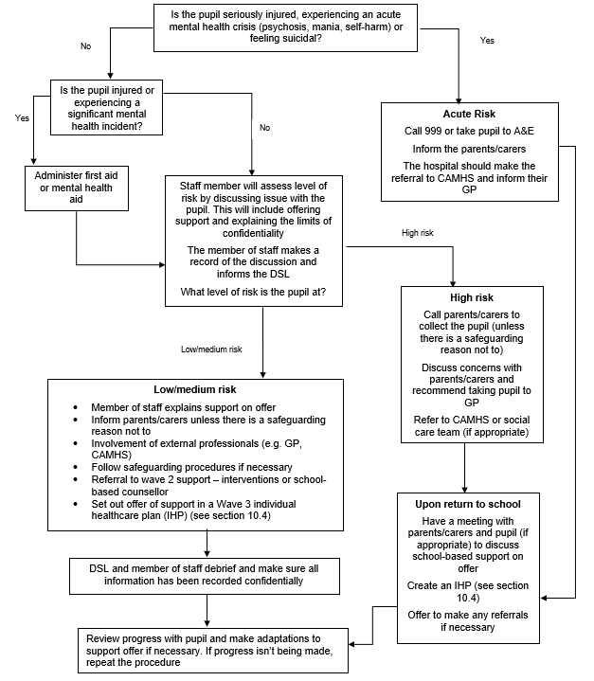

5. Warning signs
All staff will be on the lookout for signs that a pupil's mental health is deteriorating. Some warning signs include:
- Changes in:
- Mood or energy level
- Eating or sleeping patterns
- Attitude in lessons or academic attainment
- Level of personal hygiene
- Social isolation
- Poor attendance or punctuality
- Expressing feelings of hopelessness, anxiety, worthlessness or feeling like a failure
- Abuse of drugs or alcohol
- Rapid weight loss or gain
- Secretive behaviour
- Covering parts of the body that they wouldn’t have previously
- Refusing to participate in P.E. or being secretive when changing clothes
- Physical pain or nausea with no obvious cause
- Physical injuries that appear to be self-inflicted
- Talking or joking about self-harm or suicide

6. Managing disclosures
If a pupil makes a disclosure about themselves or a peer to a member of staff, staff should remain calm, non-judgmental and reassuring.
Staff will focus on the pupil’s emotional and physical safety, rather than trying to find out why they are feeling that way or offering advice.
Staff will always follow our school’s safeguarding policy and pass on all concerns to the DSL/ mental health lead. All disclosures are recorded and stored in the pupil’s confidential child protection file.
When making a record of a disclosure, staff should record on CPOMS under Mental Health category and will include:
- The full name of the member of staff who is making the record
- The full name of the pupil(s) involved
- The date, time and location of the disclosure
- The context in which the disclosure was made
- Any questions asked or support offered by the member of staff

7. Confidentiality
Staff will not promise a pupil that they will keep a disclosure secret – instead they will be open about the limits of confidentiality.
A disclosure cannot be kept secret because:
- Being the sole person responsible for a pupil’s mental health could have a negative impact on the
member of staff’s own mental health and wellbeing
- The support put in place for the pupil will be dependent on the member of staff being at school
- Other staff members can share ideas on how to best support the pupil in question
Staff should always share disclosures with at least one appropriate colleague. This will usually be the DSL/ mental health lead. If information needs to be shared with other members of staff or external professionals, it will be done on a need-to-know basis.

Before sharing information disclosed by a pupil with a third party, the member of staff will discuss it with the pupil and explain:
- Who they will share the information with
- What information they will share
- Why they need to share that information
Staff will attempt to receive consent from the pupil to share their information, but the safety of the pupil comes first.
Parents/carers will be informed unless there is a child protection concern. In this case the safeguarding policy will be followed.
7.1 Process for managing confidentiality around disclosures
- Pupil makes a disclosure
- Member of staff offers support
- Member of staff explains the issues around confidentiality and rationale for sharing a disclosure with DSL/mental health lead
- Member of staff will attempt to get the pupil’s consent to share – if no consent is given, explain to the pupil who the information will be shared with and why
- Member of staff will record the disclosure on CPOMS and share the information with the chosen elected member of staff
- The DSL/mental health lead will inform the parent/carer (if appropriate)
- Any other relevant members of staff or external professionals will be informed on a need-to-know basis

Supporting pupils

8.1 Baseline support for all pupils
In Winford we use the Boxall Profile to monitor and assess the SEMH need of ALL children with identified need.
As part of our school’s commitment to promoting positive mental health and wellbeing for all pupils, our school offers Wave 1 support to all pupils by:
- Raising awareness of mental health during assemblies, lesson time, PSHE and mental health awareness week
- Signposting all pupils to sources of online support on our school website
- Having open discussions about mental health during lessons
- Providing pupils with avenues to provide feedback on any elements of our school that is negatively impacting their mental health
- Appointing a senior mental health lead with a strategic oversight of our whole school approach to mental health and wellbeing
- Offering pastoral support, e.g. through class teachers and TAs
- Making classrooms a safe space to discuss mental health and wellbeing through interventions such as:
- Worry boxes
- Circle time
8.2 Assessing what further support is needed
If a pupil is identified as having a mental health need through the Boxall Profile, the SENDCo / Mental Health Lead will follow the LSP Graduated response to assessing the support our school can provide, further to the baseline support detailed above in section 8.1.
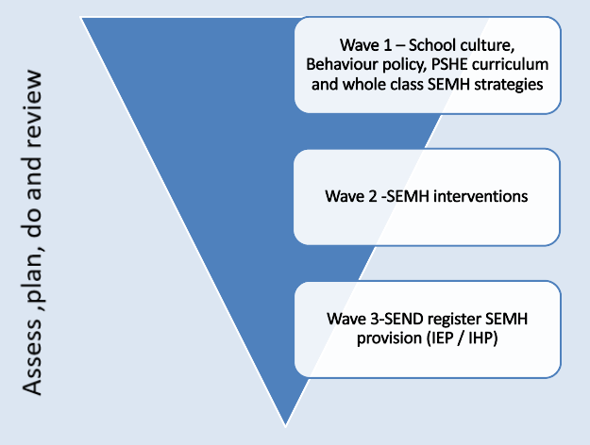
Our school will offer support in cycles of:
- Assessing what the pupil’s mental health needs through the Boxall Profile
- Creating a plan to provide support e.g through an intervention or where appropriate a bespoke individual plan.
- Taking the actions set out in the plan/ delivering the intervention
- Reviewing the effectiveness of the support offered.

8.3 Internal mental health interventions at Wave 2

Where appropriate, a pupil may be offered support that is tailored to their needs as part of the graduated approach detailed above at Wave 2 The support offered at our school includes:
- Reduced timetable
- Time-out pass/quiet places to work
- Counselling
- The LSP Pastoral Support Plan (PSP)
- The LSP SEMH graduated toolkit can help with further ideas for Wave 2 interventions.

8.4 Individualised support at Wave 3.

A pupil will be offered an individual healthcare plan (IHP) or additional mental health targets of an individual SEND plan if already in place if there is not a suitable Wave 2 Intervention, or where the Wave 2 intervention has not led to an improvement or where it is advised by an external professional that this is the best course of action.
IHPs or individual SEND plans are written in collaboration with the pupil (if appropriate), their parent/carer, and any other relevant professionals.
The pupil’s IHP or individual SEND plans will contain the following details:
- The mental health issue (and its triggers, signs, symptoms and treatments)
- The pupil's needs resulting from the condition
- Specific support for the pupil’s educational, social and emotional needs
- Risk Assessment (if needed)
- The level of support needed
- Who will provide the support
- Who in our school needs to be aware of the child’s condition
- What to do in an emergency
- When the plan will be reviewed and what success will look like.
Proforma for IHP is required can be found clicking on this link ( see pg 4-5)

8.5 Making external referrals

If a pupil’s needs cannot be met by the internal offer our school provides, our school will make, or encourage parents/carers to make, a referral for external support.
A pupil could be referred to:
- Their GP or a paediatrician
- CAMHS
- Mental health charities (e.g. Samaritans, Mind, Young Minds, Kooth)
- Local counselling services

9. Supporting and collaborating with parents/carers
We will work with parents/carers to support pupils’ mental health by:
- Asking parents/carers to inform us of any mental health needs their child is experiencing. Informing parents/carers of mental health concerns that we have about their child
- Engaging with parents/carers to understand their mental health and wellbeing issues, as well as that of their child, and support them accordingly to make sure there is holistic support for them and their child
- Highlighting sources of information and support about mental health and wellbeing on our school website, including the mental health and wellbeing policy
- Liaising with parents/carers to discuss strategies that can help promote positive mental health in their child
- Providing guidance to parents/carers on navigating and accessing relevant local mental health services or other sources of support (e.g. parent/carer forums)
- Keeping parents/carers informed about the mental health topics their child is learning about in PSHE, and share ideas for extending and exploring this learning at home
When informing parents/carers about any mental health concerns we have about their child, we will endeavour to do this face-to-face.
These meetings can be difficult, so our school will ensure that parents/carers are given time to reflect on what has been discussed, and that lines of communication are kept open at the end of the meeting.
A record of what was discussed, and action plans agreed upon in the meeting will be recorded and added to the pupil’s confidential record.
If appropriate, an Individual Healthcare Plan (IHP) or individual SEND plan will be created in collaboration with parents/carers (see section 10.4).

10. Supporting peers
Watching a friend experience poor mental health can be very challenging for pupils. Pupils may also be at risk of learning and developing unhealthy coping mechanisms from each other.
We will offer support to all pupils impacted by mental health directly and indirectly. We will review the support offered on a case-by-case basis. Support might include:
- Strategies they can use to support their friends
- Things they should avoid doing/saying
- Warning signs to look out for
- Signposting to sources of external support

11. Signposting
Sources of support are displayed around our school and linked to on our school website, so pupils and parents/carers are aware of how they can get help.
The DSL/Mental Health Lead or SENCo will be available to provide further information to pupils and parents/carers if they want to learn more about what support is available.
See website of one of the above members of staff for details of this.

12. Whole school approach to promoting mental health awareness
12.1 Mental health is taught in PSHE
We follow the PSHE Association Guidance teaching mental health and emotional wellbeing.
Pupils are taught to:
- Develop healthy coping strategies
- Challenge misconceptions around mental health
- Understand their own emotional state
- Keep themselves safe
For more information, see our PSHE curriculum based on Jigsaw.
12.2 Creating a positive atmosphere around mental health
Staff will create an open culture around mental health by:
- Discussing mental health with pupils in order to break down stigma
- Encouraging pupils to disclose when their mental health is deteriorating

13. Training
All staff will be offered training so they:
- Have a good understanding of what pupils’ mental health needs are
- Know how to recognise warning signs of mental ill health
- Know a clear process to follow if they identify a pupil in need of help
- Understand the 6 principles of Nurture

14. Support for staff
We recognise that supporting a pupil experiencing poor mental health can affect that staff member’s own mental health and wellbeing. To help with this we will:
Outline the support offered to staff, e.g.
- Treat mental health concerns seriously
- Offer staff supervision sessions
- Support staff experiencing poor mental health themselves
- Create a pleasant and supportive work environment
- Offer an employee assistance programme (LSP Gateway)

15. Monitoring arrangements
This policy will be reviewed by the Mental Health Lead and SENCo annually. At every review, the policy will be approved by the Headteacher and shared with the governing body.

